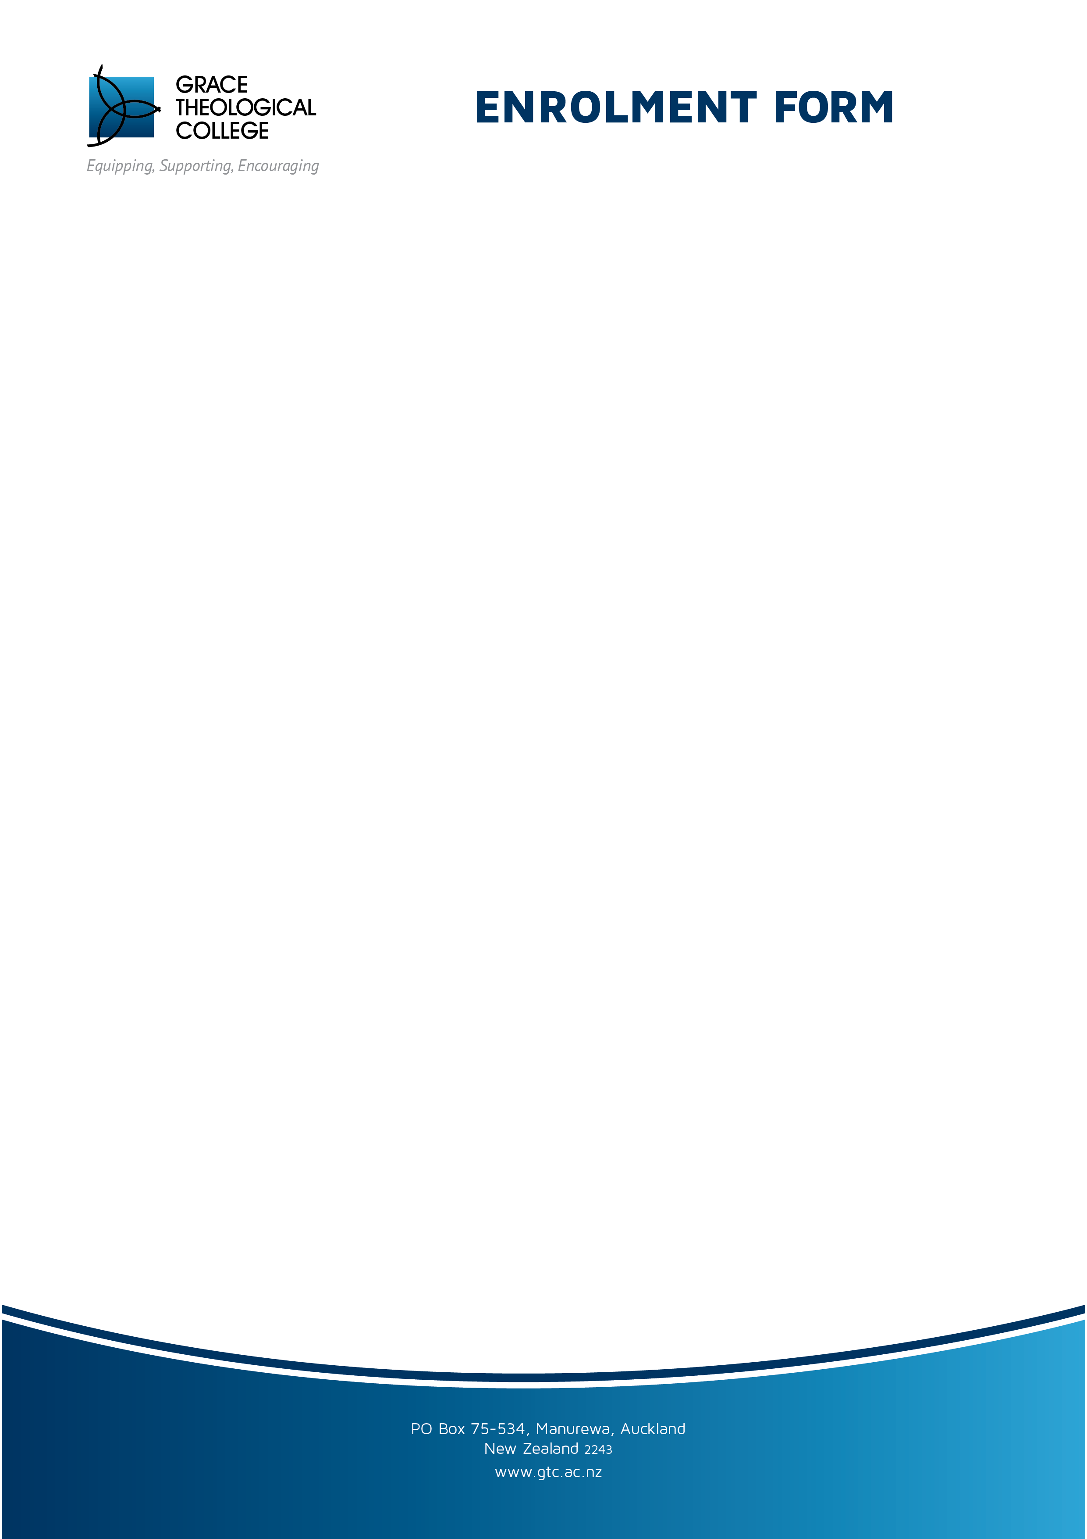

**Location of Study:** ……..................................... *Year* ........................

## PERSONAL INFORMATION

*First Name:* ………….…………………… *Last Name:* ………………………………………

*Address* ……………..……………….………………………………………………………………

.............................................................................................. *Postcode*..................................

*Phone* .................................................. *Mobile* ..........................................................

*Email* .....................................................................................................................................

## HOME CHURCH: …………………….........................................

## EDUCATIONAL INFORMATION: (Highest qualification)

*Qualification: ……………………………..* GraduationYear:………...

*School:* *……………………....................*

*Certificate you plan on completing:* ………… (CBS, CCM, CPM, or BTS Masters*)

***Course/s (papers) you are enrolling in:***

1.……………………………………… (code: ) ( Credit/Audit)*

2……………………………………….. (code: ) ( Credit/Audit)

3. ……………………………………… (code: ) ( Credit/Audit)

4……………………………………….. (code: ) ( Credit/Audit)

5………………………………............. (code: ) ( Credit/Audit)

*Study for credit is $**375.00** per class and involves assessment tasks. Audit is personal study and costs $**188.00**

**Signed:** ……………………………...................................

*To fill in, type directly onto the document and email back to us. Or, scan or photograph and email to: geoff.macpherson@gtc.ac.nz . Otherwise, print and post to the address below.*

*\*Those students with an existing degree may be able to gain credit with Birmingham Theological Seminary*